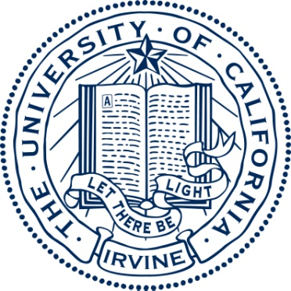

**Chancellor’s Award of Distinction**

The Chancellor’s Award of Distinction acknowledges the University of California, Irvine’s most outstanding graduating seniors. Presented in collaboration with the UC Irvine Alumni Association, these students represent exceptional academic achievement, and a commitment to cutting-edge research, leadership and service to UCI. The blue and gold shoulder cord worn with their commencement regalia identifies recipients.

**Taylor Yuriko Ainslie**

School of Humanities

**Jaime Allen**

School of Social Sciences

**Rahaf Baker**

School of Biological Sciences

**Nirav Bhardwaj**

The Paul Merage School of Business

**Colin** **Campbell**

School of Biological Sciences

**Jane Yoona Chung**

School of Humanities

School of Social Sciences

**Alexandra Genevieve** **Coombs**

Program in Public Health

School of Social Sciences

**Annie Stanfield** **Ditta**

School of Social Sciences

**Ryan** **R. Garcia**

The Henry Samueli School of Engineering

**Brandon Haghverdian**

School of Biological Sciences

**Stephanie** **Cheng Hammel**

School of Biological Sciences

School of Physical Sciences

**Douglas Cuong** **Huynh**

The Henry Samueli School of Engineering

**Helen Katherine** **Klein**

School of Humanities

School of Social Sciences

**Eileen Huang** **Lee**

School of Social Ecology

School of Social Sciences

**Ramon Lee** **Jr.**

School of Social Ecology

**Aaron M. Levin**

The Paul Merage School of Business

**John** **Naviaux**

School of Physical Sciences

School of Social Sciences

**Albert Timothy** **Novelozo**

School of Social Ecology

**Kevin** **Tuan** **Phan**

School of Biological Sciences

**Amy Elizabeth Quanbeck**

Claire Trevor School of the Arts

**Richard** **G. Ramos**

School of Social Sciences

**Emily Rong**

The Paul Merage School of Business

**Nellie Jamal** **Said**

School of Biological Sciences

**Loren Marie Salkin**

School of Humanities

**Erika Santacruz**

School of Social Sciences

**Amanda Schneider**

School of Humanities

**Madiha** **Shahabuddin**

School of Social Sciences

**Steven D.** **Tate**

School of Biological Sciences

**Xuan Amelia Tran**

School of Biological Sciences

School of Physical Sciences

**Thanh Dieu Truong**

Program in Public Health

School of Social Ecology

**Jack** **Williams IV**

School of Humanities

**Karen Zhou**

The Paul Merage School of Business